UGN2 Task 1: Linear Regression Analysis

Jade Ferguson
Student Number: 012475408
Western Governors University

Abstract
In this assignment, I used multiple linear regression to analyze residential housing data and determine which property features and neighborhood characteristics best predict home selling prices and the market overall. The goal of this analysis was to develop a model that identifies factors that have the strongest influence on housing values and can be used to support data-driven pricing decisions.

A: Describe the purpose of this data analysis by doing the following:
- Purpose one research question is relevant to a real-world organizational situation captured in the dataset provided that you will answer using multiple linear regression.
Which combination of property features and neighborhood characteristics best predicts residential property selling prices, and which factors have the strongest impact on price?
- Define one goal of the data analysis. Ensure that your goal is relevant within the scope of the scenario and is represented in the available data
The goal of this data analysis is to develop a multiple linear regression model that identifies and quantifies the property and neighborhood characteristics that most strongly influence residential property selling prices.
B: Summarize the data preparation process for multiple linear regression analysis by doing the following using Python or R:
- Identify the dependent variable and 10 or more independent variables that are required to answer the research question to justify your selection of variables.
Dependent Variable: Price
Price represents the market value of a property and is a continuous variable, which is suitable for multiple linear regression.
Independent Variables:
- Square Footage
  - Larger homes generally command a higher price as they provide more living space.
- NumBathrooms
  - The homes that usually have more bathrooms are more desirable, especially for large families.
- NumBedrooms
  - Additional bedrooms mean that the property can have more residents, which can appeal to big families.
- BackyardSpace
  - A larger outdoor area can make a property more appealing, especially for families, pet owners, or buyers looking for an area to relax.
- CrimeRate
  - Higher crime rates may reduce property values because most buyers prefer areas with little to no crime.
- SchoolRating
  - For growing families and families with kids, high-rated schools are important and in demand, as most parents want their kids to have a good education.
- AgeOfHome
  - Older properties may have a lower value due to maintenance needs, while newer ones may have premium prices. But there is the factor of historical homes as well.
- DistanceToCityCenter
  - Properties closer to where people work, shop, and get services, such as an oil change, can often have higher values due to convenience.
- EmploymentRate
  - Areas that have a higher employment rate are generally a strong indicator of a strong local economy, which means housing demand is higher.
- PropertyTaxRate
  - Higher property taxes may discourage some buyers and reduce demand, which can lower prices.
- RenovationQuality
  - High-quality renovations can improve a property's appearance, functionality, and value, which makes it appealing to buyers at this higher price.
- LocalAmentities
  - Access to parks, shopping, and recreational places can increase a neighborhood, especially for families.
- TransportAccess
  - Convenient access to public transportation can increase property appeal and price.
- Fireplace
  - A fireplace is considered a feature many want, as it's a luxury that can affect the selling price.
- Garage
  - Having a garage provides an area for storage, which adds value, especially given how big it is, such as a 1-, 2-, or 3-car garage.
- Floors
  - The number of floors may indicate more space, which can affect the selling price.
- Windows
  - More windows mean more natural lighting, which can enhance the property value.
- PreviousSalePrice
  - Previous sale price reflects the underlying market value and can serve as a strong indicator of the current selling price.
- IsLuxury
  - Luxury homes usually contain features such as a pool and amazing locations, such as one with a view, and are made with materials that will last for years.
- Provide at least one screenshot of the descriptive statistics (e.g., mean, median, range, standard deviation, variance, percentiles, quartiles) for the quantitative variables selected from B1 and for the qualitative variables if selected. 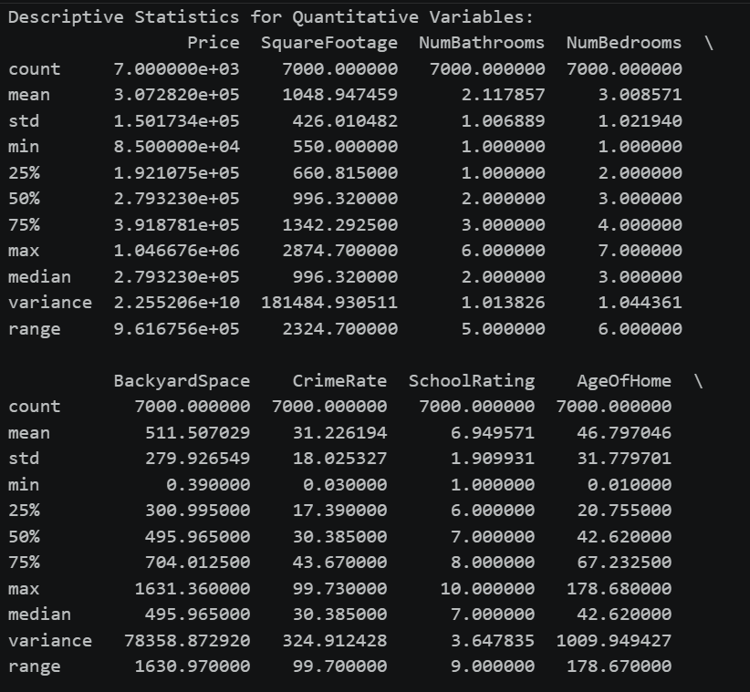
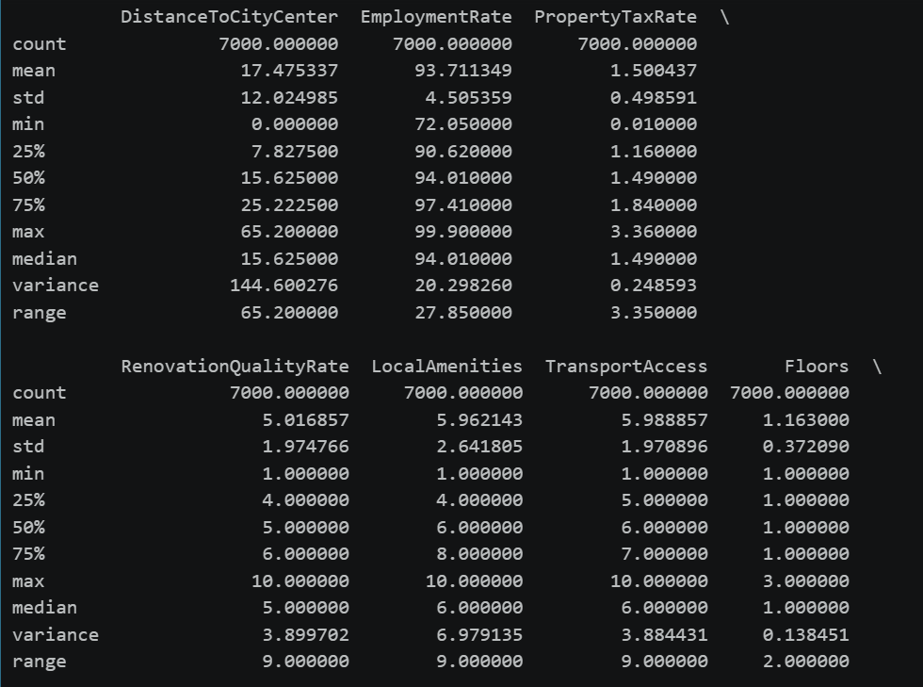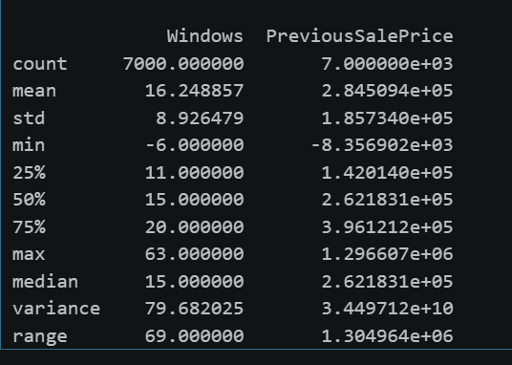

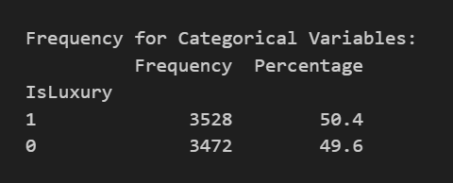
- Generate univariate and bivariate visualizations of the distributions of the dependent and independent variables from part B1, including the dependent variable in the bivariate visualizations
  - In code
C. Perform the data analysis and report on the results by doing the following using Python
- Split the data into two datasets, with a larger percentage being assigned to the training set and a smaller percentage assigned to the test dataset. Provide at least one screenshot.
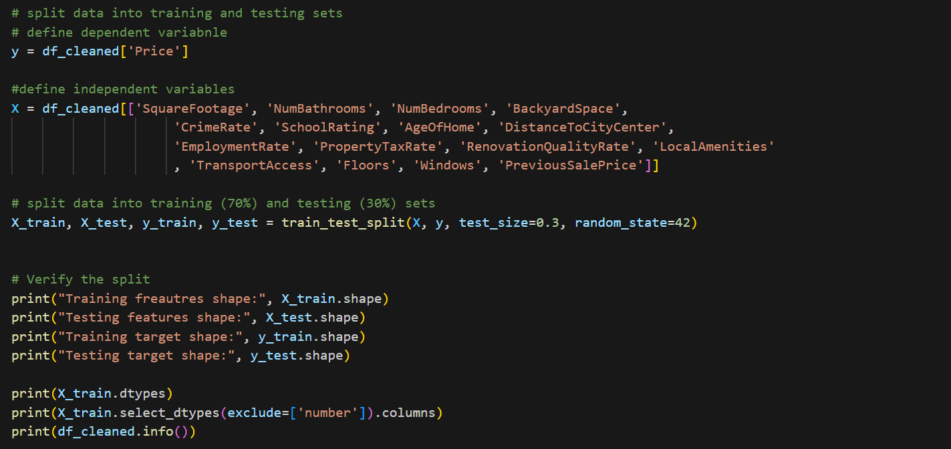
3. Create a screenshot of the summary of the initial linear regression model
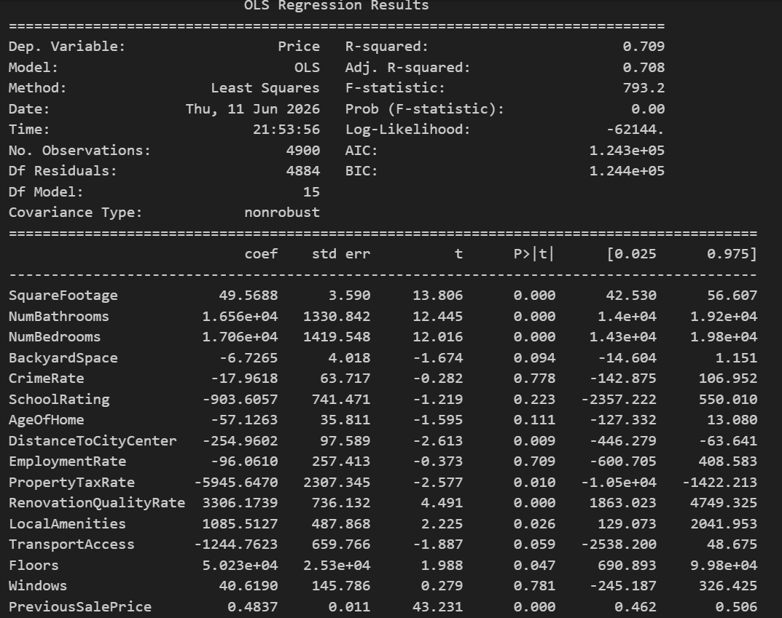
5. Create a screenshot of the summary of the optimized model
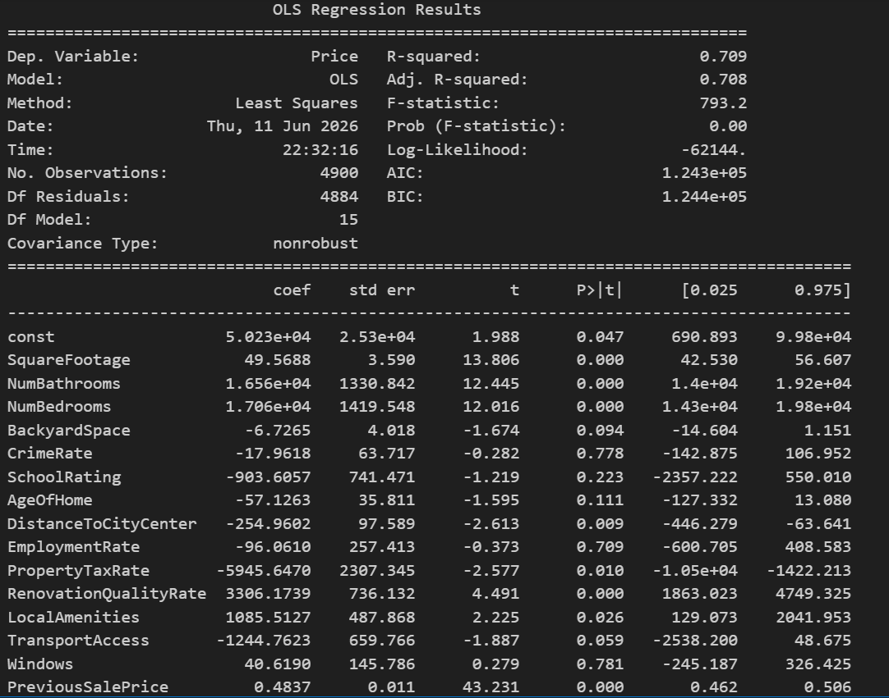
6. Root mean squared error (RMSE) screenshot
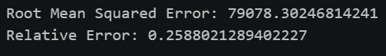
D. Summarize your data analysis by doing the following
- List packages or libraries you have chosen for Python and justify each item on the list that supports the analysis.
- Pandas (import as pandas as pd):
  - The purpose is for data loading, cleaning, transforming, and descriptive analysis. It's also efficient in data manipulation, which makes it easier for exploratory data analysis and preprocessing.
- NumPy (import numpy as np):
  - NumPy is great for numerical computations and data processing; it was used to perform mathematical operations and figure out outliers.
- Matplotlib (import matplotlib.pyplot as plt)
  - Matplotlib is great for data visualization; it was used to create the histograms, scatterplots, bar charts, and boxplots. The visualizations help with assessing variable distributions, relationships, and potential outliers.
- Scikit-learn Model Selection (from sklearn.model_selection import train_test_split):
  - The purpose of this is for dataset partitioning. The train_test_split() function was used to divide the dataset into 70% for training and 30% subsets. This separation allows for the model performance to be evaluated on unseen data and helps with assessing the model's ability to generalize.
- Statsmodels (import statsmodels/.api as sm):
  - This helps with multiple linear regression modeling and statistical inference. The statsmodel was used to build an OLS, or Ordinary Least Squares, regression model that provides statistical outputs that include things such as coefficient estimates, p-values, confidence intervals, R-square values, and model diagnostics that support interpretation of predictor significance.
- Scikit-learn Preprocessing (from sklearn.preprocessing import StandardScaler):
  - Standard scaler helps with feature standardization of predictor variables before Elastic Net Regression. It ensures that variables measured on different scales contribute the same to the process and prevents variables such as larger outliers from dominating the model.
- Scikit-learn Linear Models (from sklearn.linear_model import ElasticNet, ElasticNetCV):
  - This helps with variable selection and regularized regression. Elastic Net regression was used to address the multicollinearity among predictors and to perform variable selection. The ElasticNetCV function automatically identifies the optimal regularization parameters through cross-validation, helping to improve model stability and reduce overfitting.
- Scikit-learn Metrics (from sklearn.metrics import mean_squared_error):
  - It helps with model performance evaluation. The mean_squared_error() function was used to calculate root mean squared error (RMSE), which measures the average prediction error of the final model.
3. Discuss the method used to optimize the model, providing justification for the approach.
The initial multiple linear regression model included these explanatory variables: SquareFootage, NumBathrooms, NumBedrooms, BackyardSpace, CrimeRate, SchoolRating, AgeOfHome, DistanceToCityCenter, EmploymentRate, PropertyTaxRate, RenovationQualityRate, LocalAmenities, TransportAccess, Floors, Windows, and PreviousSalePrice
To optimize the model, Elastic Net regression with cross-validation (ElasticNetCV) was used as a variable selection technique. The Elastic Net combines the penalties of both Lasso (L1) and Ridge (L2) regression. This approach was selected because several characteristics of housing were expected to be correlated with one another,, which creates multicollinearity that can lead to unstable coefficient estimates in OLS regression. Before running Elastic Net, all predictor variables were standardized using StandardScaler to ensure that variables measured on different Scales contribute equally to the realization process. ElasticNetCV was then applied using five-fold cross-validation and multiple values of the mixing parameter (l1_ratio = 0.1, 0.3, 0.5, 0.7, and 0.9). Cross-validation automatically identified the optimal level of regularization based on model performance. Variables with coefficients near zero after Elastic Net regularization were removed from the model, which was Floors, as the coefficient reduced to 0.000 and was removed from the model. While variables with meaningful coefficients were kept, which were SquareFootage, NumBathrooms, NumBedrooms, BackyardSpace, CrimeRate, SchoolRating, AgeOfHome, DistanceToCityCenter, EmploymentRate, PropertyTaxRate, RenovationQualityRate, LocalAmenities, TransportAccess, Windows, PreviousSalePrice
The kept variables were used to fit a final OLS regression model. The model achieved an R-squared value of 0.709, indicating that approximately 70.9% of the variation in housing prices was explained by the selection of predictors. This approach reduced model complexity, mitigated multicollinearity, and improved interpretability while maintaining predictive accuracy.
Model performance was evaluated using root mean squared error (RMSE). The optimized model achieved an RMSE of 79078.30 and a relative error of 25.88%, indicating that the model predictions were reasonably accurate given the variability of housing prices.
3. Complete the following for the optimized model:
- Create a regression equation by using the coefficients from the optimized model
  - Price = 50,230 + 49.57(SquareFootage) + 16,560(NumBathrooms) + 17060(NumBedrooms) - 6.73(BackyardSpace) - 17.96(crimeRate) - 903.61(SchoolRating) - 57.413(AgeOfHome) - 254.96(DistanceToCityCenter) - 96.06(EmploymentRate) - 5945.65(PropertyTaxRate) + 3306.17(RenovationQualityRate) + 1085.51(LocalAmenities) - 1244.76(TransportAccess) + 40.62(Windows) + 0.484(PreviousSalePrice)
- Provide an Interpretation for each coefficient in the regression equation
  - The intercept is 50230, which means that the predicted home price is when all predictor values are zero.
  - SquareFootage is 49.57 and means that each additional square foot increases the predicted home price by approximately $49.57.
  - NumBathrooms is 16560, and means that each additional bathroom increases the predicted home by approximately $16560.
  - NumBedroms is 17060 and means that each additional bathroom increases the predicted home value by approximately $16560.
  - BackyardSpace is -6.73, which means that each additional unit of backyard space decreases the predicted price by $6.73
  - CrimeRate is -17.96, so in each one-unit increase in crime rate, it decreases the predicted price by approximately $17.96.
  - AgeOfHome is -57.13, which means that each additional year a home's age decreases the predicted value by approximately $57.13.
  - DistanceToCityCenter is -254.96, and with each additional unit of distance from the city center, it decreases the predicted price by approximately $254.96.
  - EmploymentRate is -96.06, which means that each one-unit increase in employment rate decreases the predicted price by $96.06.
  - PropertyTaxRate is -5945.65, which means that each one-unit increase in property tax rate decreases the predicted home price by approximately $5945.65.
  - RenovationQualityRate is 3306.17, which means that a 1-unit increase in renovation quality increases the projected home price by approximately $3306.17.
  - LocalAmenities is 1085.51, which means that each additional local amenity increases the predicted home price by approximately $1085.51.
  - TransportAccess is -1244.76, which means each one-unit increase in transport access decreases the predicted home price by approximately $1244.76.
  - Windows is 40.62, which means that each additional window increases the predicted home price by approximately $40.62.
  - PreviousSalePrice is 0.484; for every additional $1 in previous sale price, the current predicted home price increases by approximately $0.48.
- Discuss the adjusted R^2
  - The optimized model proceeds with an adjusted R^2 value of 0.708. This indicates that approximately 70.8% of the variation in housing prices is explained by the predictor variables included in the model after accounting for the number of predictors used. The adjusted R^2 is preferred over the regular R^2 because it penalizes the inclusion of unnecessary variables. An adjusted R^2 of 0.708 suggests that the model has explanatory power and that the selected variables collectively provide a good explanation of housing price variation.
- Discuss the accuracy of the optimized model with that of the rest of the test dataset based on the RMSE
  - The optimized model achieved a root mean squared error (RMSE) of 79078.30 on the test dataset. RSME measures the average prediction error in the same units as the dependent variable (dollars). This means that the model’s predictions differ from the actual housing prices by approximately $79,078 on average. The relative error was calculated as 79078.30/305.548 = 0.2588 or 25.88%. This indicates that the model’s prediction error is about 25.9% of the average home price. Considering the inherent variability in housing markets and the large number of factors that can influence property values, the model demonstrates reasonable predictive accuracy and generalizes adequately to unseen data.
4. Summarize at least two assumptions of multiple linear regression.
The first assumption is that the linearity assumption states that there should be a linear relationship between the dependent variable (Price) and each independent variable. This assumption was evaluated using scatterplots comparing Price to several predictor variables. The plots generally showed linear trends, indicating that multiple linear regression was an appropriate modeling technique.
The second assumption is that multiple linear regression assumes that extreme outliers do not exert undue influence on the model results. Outliers were identified using the Interquartile Range (IQR) method and visualized through boxplots. Rather than removing observations, winsorization was applied to cap values outlying the lower and upper IQR bounds. This approach reduced the influence of extreme values while retaining all observations in the dataset.
5. Provide evidence that the assumptions from part D4 were verified by providing code snippets or screenshots.
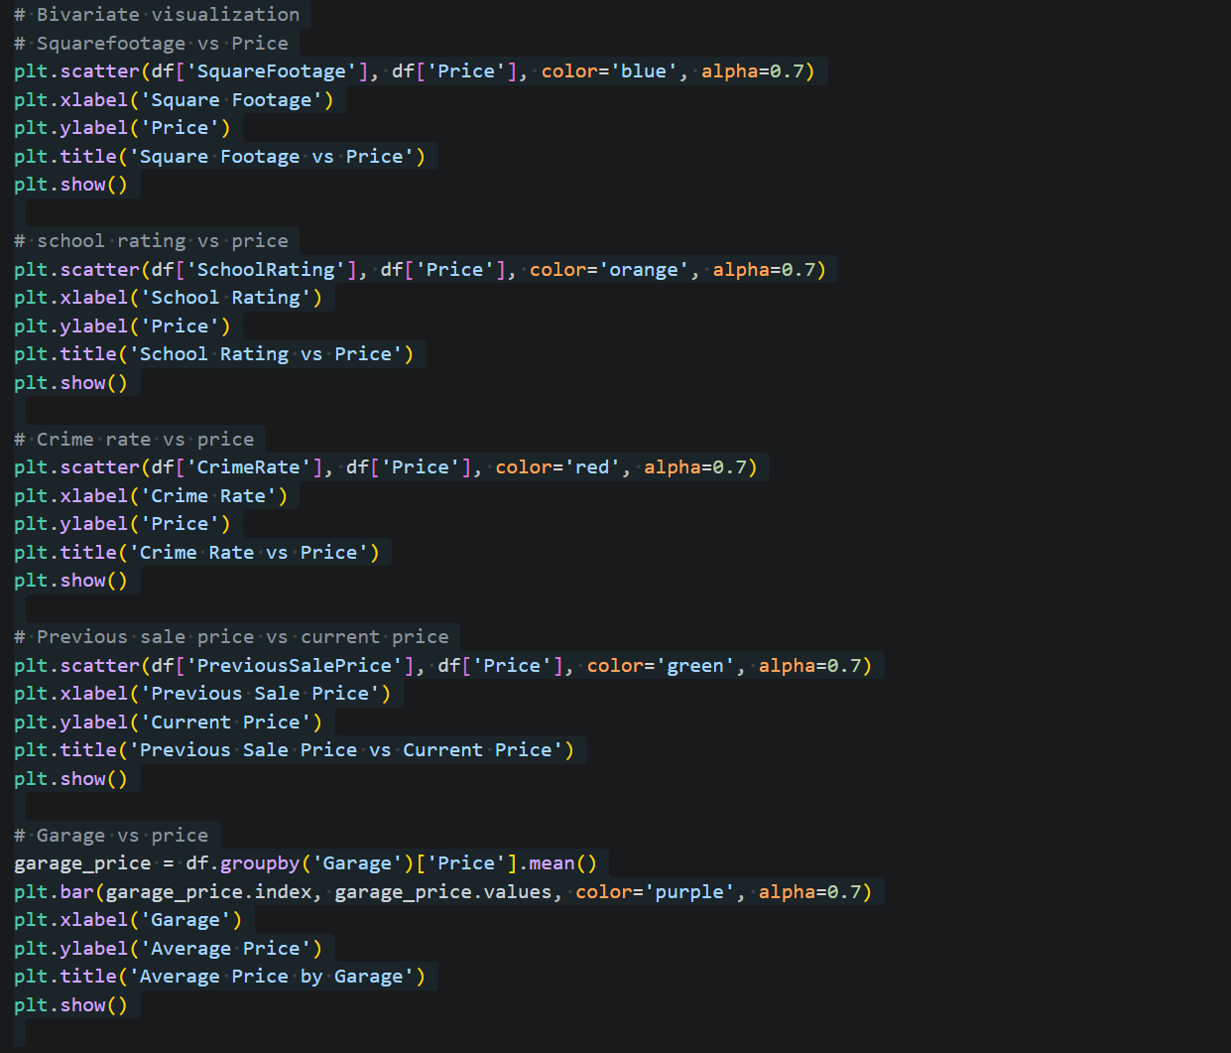
These visualizations were examined to verify that approximately linear relationships existed between the predictors and housing prices.
For outliers, the following code was used to identify outliers using the IQR method, which results indicated the presence of several outliers, which were mitigated through winsorization before model development.
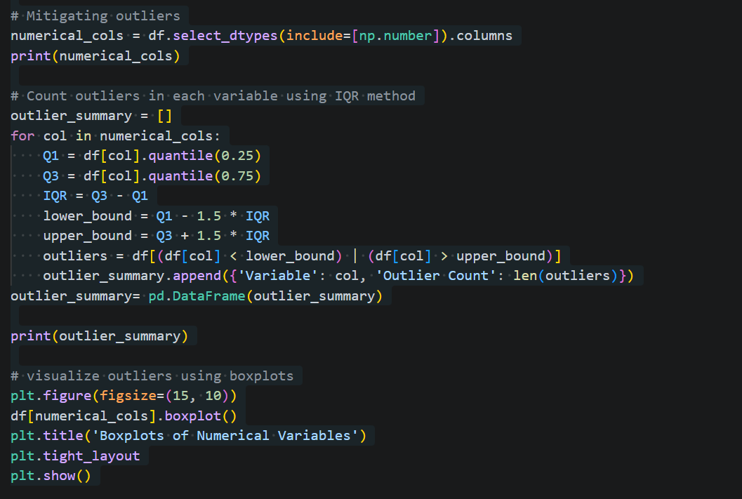
6. Discuss a limitation of your analysis.
One limitation of my analysis is that the model only explains approximately 70.8% of the variation in housing prices, as indicated by the adjusted R^2 value. Although this represents strong exploratory power, approximately 29.2% of the variation remains unexplained. Factors not included in the dataset, such as desirability of the neighborhood, the economy, market trends, property condition, and more, may affect housing prices. Additionally, the model achieved an RMSE of $79,078, indicating that individual predictions may still differ substantially from actual sale prices.
7. Recommended course of action for the real-world organization situation from part A1 based on the results of your data analysis.
Based on the optimized regression model, the organization should focus on the variables that demonstrated the strongest influence on housing prices when evaluating properties and forecasting market values. PreviousSalePrice, SquareFootage, NumOfBedrooms, NumOfBathrooms, and RenovationQualityRate were among the most influential predictors retained in the final model. The organization should prioritize these factors when estimating home values, assessing investment values, and making pricing decisions. In particular, investments in property renovations and improvements that increase functional living space may yield a higher property value. The model can also be incorporated into the organization's decision-making process to provide data-driven estimates of housing prices and support strategic planning.

Citations
No sources were cited or used

